LAB EXPERIMENT RECORD
Set 24: Product Inventory Management

Department | AIML
Course Code / Course Name | DSA0601 / Data Handling and Visualization
Experiment | Data Visualization using R
Name | G. Ganga Chandrika
Register Number | 1925260144
Date | 17 October 2026
Day | Saturday

Aim
To visualize product inventory data using a bar chart, a stacked bar chart, and a scatter plot, and to build a dashboard that combines the bar chart and stacked bar chart for exploring the inventory data.
Dataset: Product Inventory
Product ID | Product Name | Quantity Available
1 | Product A | 250
2 | Product B | 175
3 | Product C | 300
4 | Product D | 200
5 | Product E | 220

PROGRAM 1: Bar Chart of Product Inventory
Create a bar chart to visualize the quantity of each product in the inventory. Label the axes and title the chart.
# Create product inventory dataset
product <- c("Product A", "Product B", "Product C",
"Product D", "Product E")
quantity <- c(250, 175, 300, 200, 220)
# Create bar chart
barplot(quantity,
names.arg = product,
col = "skyblue",
main = "Product Inventory Quantity",
xlab = "Product Name",
ylab = "Quantity Available",
ylim = c(0, 350))
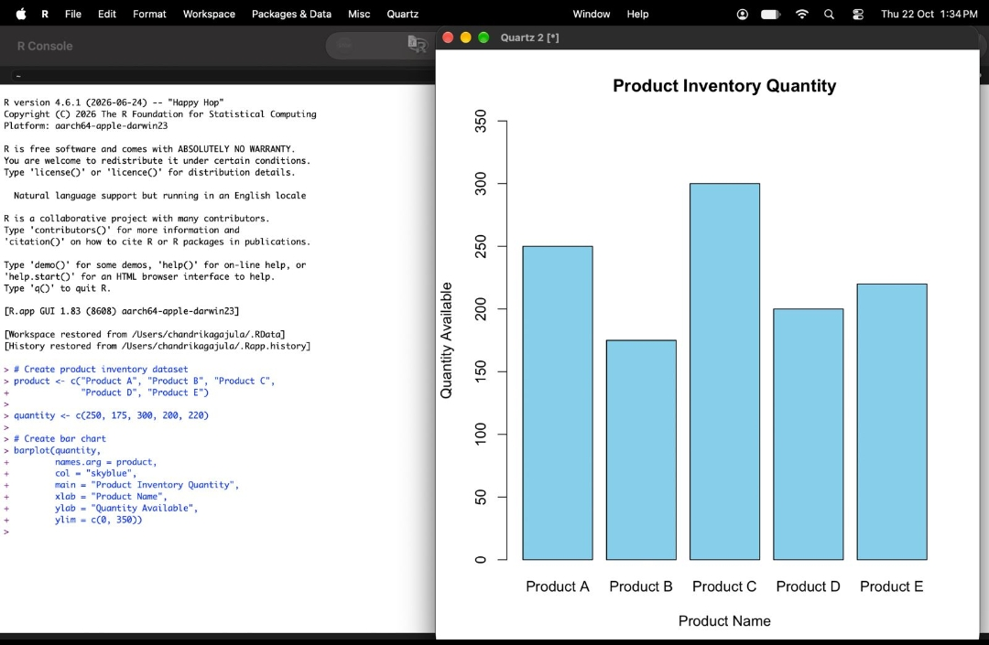
Output 1: Product Inventory Quantity Bar Chart
Observation: Product C has the highest quantity (300) and Product B has the lowest (175). Products A, D, and E lie in between at 250, 200, and 220 respectively.

PROGRAM 2: Stacked Bar Chart by Product Category
Generate a stacked bar chart to show the quantity of each product within different product categories.
# Create inventory data by category
inventory <- matrix(c(150, 100,
100, 75,
180, 120,
120, 80,
140, 80),
nrow = 5, byrow = TRUE)
rownames(inventory) <- c("Product A", "Product B",
"Product C", "Product D",
"Product E")
colnames(inventory) <- c("Category 1", "Category 2")
# Create stacked bar chart
barplot(t(inventory),
beside = FALSE,
col = c("lightblue", "orange"),
main = "Product Inventory by Category",
xlab = "Product Name",
ylab = "Quantity Available",
legend.text = TRUE,
args.legend = list(x = "topright"))
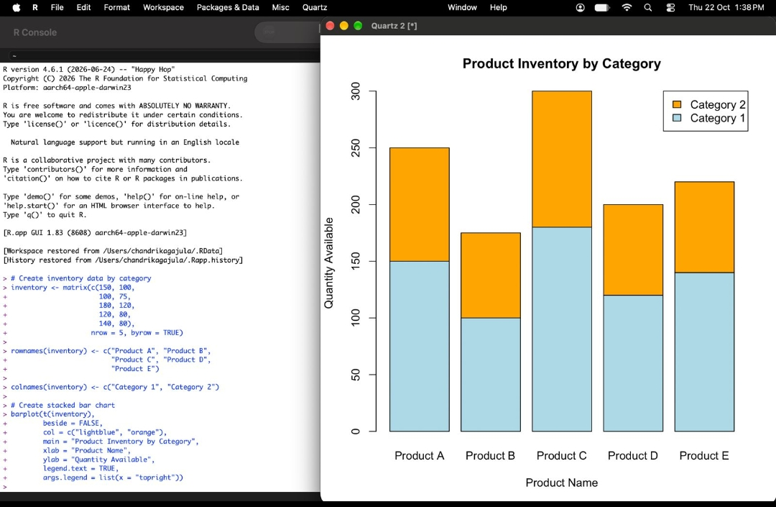
Output 2: Product Inventory by Category Stacked Bar Chart
Observation: Each bar is split into Category 1 and Category 2, and the two parts add up to the product's total quantity (for example, Product A: 150 + 100 = 250). Category 1 contributes the larger share for every product.

PROGRAM 3: Inventory Dashboard
Build a dashboard combining the bar chart and stacked bar chart for exploring the inventory data.
# Load required packages
library(ggplot2)
library(gridExtra)
# Product inventory dataset
inventory <- data.frame(
Product = c("Product A", "Product B", "Product C",
"Product D", "Product E"),
Quantity = c(250, 175, 300, 200, 220)
)
# Bar chart
p1 <- ggplot(inventory,
aes(x = Product, y = Quantity)) +
geom_col(fill = "skyblue") +
labs(
title = "Product Inventory",
x = "Product Name",
y = "Quantity Available"
) +
theme_minimal()
# Display chart
print(p1)
# Stacked bar chart data
category_data <- data.frame(
Product = rep(inventory$Product, each = 2),
Category = rep(c("Category 1", "Category 2"), 5),
Quantity = c(
150, 100,
100, 75,
180, 120,
120, 80,
140, 80
)
)
p2 <- ggplot(category_data,
aes(x = Product,
y = Quantity,
fill = Category)) +
geom_col() +
labs(
title = "Inventory by Category",
x = "Product Name",
y = "Quantity Available",
fill = "Category"
) +
theme_minimal()
print(p2)
# Combine both charts into one dashboard
library(gridExtra)
grid.arrange(
p1,
p2,
ncol = 2,
top = "Product Inventory Management Dashboard"
)
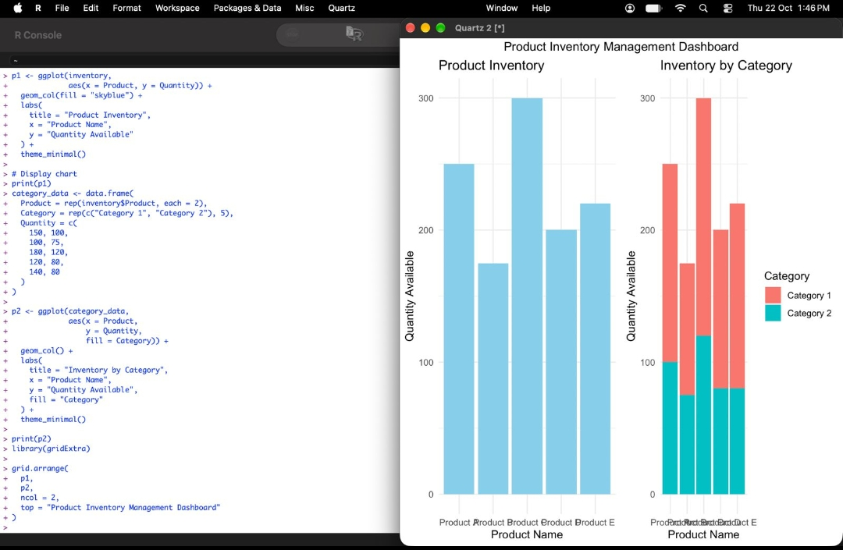
Output 3: Product Inventory Management Dashboard
Observation: The dashboard places the Product Inventory bar chart and the Inventory by Category stacked bar chart side by side, so total stock and the category split can be compared for every product in one view.

PROGRAM 4: Scatter Plot of Product Price vs Quantity Available
Create a scatter plot to explore the relationship between product price and quantity available.
# Create product inventory dataset
product <- c("Product A", "Product B", "Product C",
"Product D", "Product E")
price <- c(100, 150, 80, 120, 110)
quantity <- c(250, 175, 300, 200, 220)
# Create scatter plot
plot(price, quantity,
main = "Product Price vs Quantity Available",
xlab = "Product Price",
ylab = "Quantity Available",
pch = 19,
col = "blue")
# Add product labels
text(price, quantity,
labels = product,
pos = 3,
cex = 0.8)
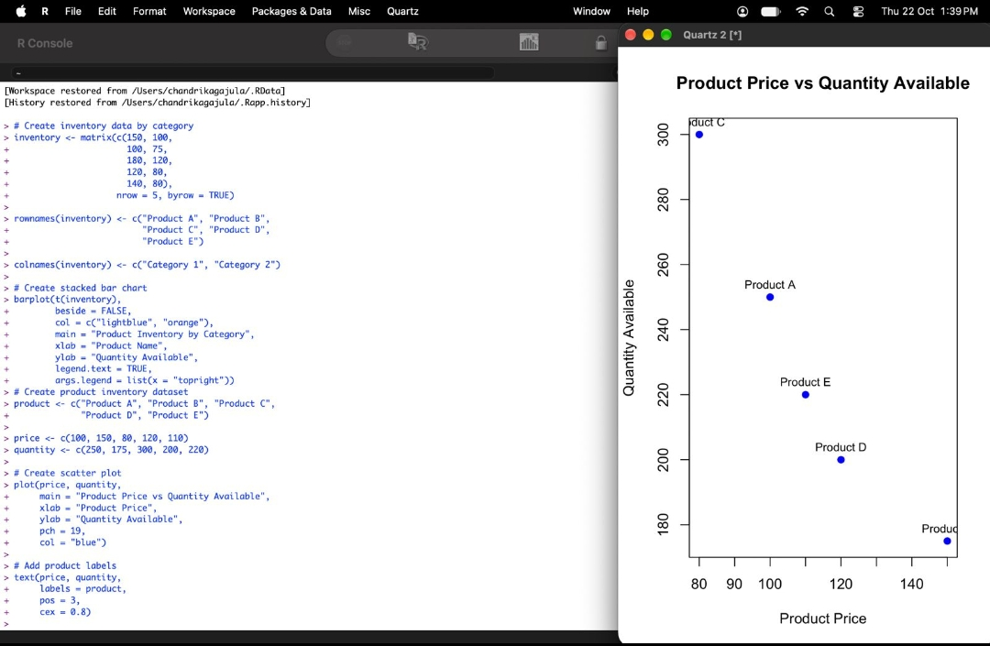
Output 4: Product Price vs Quantity Available Scatter Plot
Insight: The points show a negative relationship: as the product price increases, the quantity available decreases. Product C has the lowest price (80) and the highest quantity (300), while Product B has the highest price (150) and the lowest quantity (175). Products A (100), E (110), and D (120) fall in between, with quantity falling steadily as price rises (250, 220, 200). This suggests that lower-priced products are stocked in larger quantities, and higher-priced products are kept in smaller quantities.
Procedure
1. Create the product and quantity vectors in R.
2. Use barplot() with names.arg, main, xlab, ylab, and ylim to create the bar chart.
3. Store the category-wise quantities in a matrix, name its rows and columns, and use barplot(t(inventory), beside = FALSE) to draw the stacked bar chart.
4. Create the bar chart (p1) and the stacked bar chart (p2) with ggplot2, and combine them using grid.arrange() to form the dashboard.
5. Create price and quantity vectors of equal length, use plot() for the scatter plot, and add product names using text().
Result
The product inventory data was successfully visualized using a bar chart, a stacked bar chart, and a combined dashboard. The scatter plot showed that quantity available decreases as product price increases.
Key R Functions Used
Function | Purpose
barplot() | Creates bar charts and stacked bar charts.
matrix() | Stores the category-wise quantity data.
plot() | Creates the scatter plot.
text() | Adds product labels to the scatter plot.
ggplot() | Builds the bar chart and stacked bar chart for the dashboard.
grid.arrange() | Combines multiple charts into one dashboard.

